Table of Contents

Book Club Scholars - Configuration Requirements 1

Book Club Scholars - Customization Requirements 4

# Book Club Scholars - Configuration Requirements

Company Overview

Book Club Scholars (BCS) is an up-and-coming publishing and media distribution company that publishes and distributes children’s books to classrooms. BCS recently launched a website where teachers and parents can easily order books online and have the books shipped to the classroom.

To encourage more schools to use its website, BCS launched a new rewards program where students can earn points toward free books and other educational media for every book purchase linked to their classroom. Five points are awarded for each Gold Level book sold. Three points are awarded for each Silver Level book sold. One point is awarded for each Bronze Level book sold. Each month, teachers and/or parents can enter their book order and classroom code. At the end of the month, books marked with the student’s name are shipped directly to the classroom, and points are awarded.

Project Overview

BCS’s annual revenue has been nearly doubling every year for the past four years. Revenue is expected to exceed over $5,000,000 USD at the end of this year. The majority of BCS’s IT infrastructure was built in the first two years of the company’s existence. The original infrastructure worked well when business volumes were lower, but now BCS must upgrade its IT systems to better track Rewards Program points.

In a recent decision, the CIO of the company chose the Force.com platform to bring its business into the cloud, and plans to migrate dozens of existing applications to the Force.com platform. BCS has already started tracking its schools and classrooms using the Force.com platform, and now plans to manage Rewards Points inside Salesforce as well. The BCS administrator has already set up the data model and configuration necessary for tracking Classrooms and Rewards Program points. However, a Certified Force.com Advanced Developer is now needed to develop the requested features of the application that require programming.

Data Model Overview

This section of the document details the data model of the application, for the candidate’s reference. The data model has already been configured in the Salesforce organization provided. Salesforce Certified Force.com Advanced Developer – Programming Assignment

Entity Relationship Diagram

Below is the Entity Relationship Diagram (ERD) of the application being developed. The ERD depicts all of the objects that play a significant role and are needed to understand the application requirements.



**Account**

Accounts represent the Classroom.

Contact

Contacts represent the student who receives the product.

Contact Fields:

• **Total_Rewards_Points__c**: sum of all rewards points from all order line items for this student Roll up Summary

**Book_Order__c**

Order represents a request to purchase BCS products.

• **Last_OLI_TotalPrice__c**: It will be populated by Workflow --Currency

**Order_Line_Item__c**

Order Line Items represent the quantity and total price of a Product. Order_Line_Item__c Fields

• **Book_Order__c**: Master Detail lookup to Book Order.

• **Student__c**: Standard lookup field to Contact (student).

A validation rule ensures the Contact belongs to the Order Classroom.

If the Student__c field is blank, then the product is for the classroom, not the individual student.

• **Shipping_Status__c**: Picklist field with the following values: Pending Shipment, Shipped, Cancelled.

• **Date_Shipped__c**: Date order line item shipped.

• **Product__c**: Standard lookup / Master Detail to Product2. Standard lookup allows historical data to be imported into the system with Level and Points Rewarded, without Products.

• **Quantity__c**: # of products ordered. Number

• **Level__c**: Picklist field with the following values: Gold, Silver, Bronze. Formula product

• **Rewards_Points__c**: # of rewards points awarded for Order_Line_Item. Number

• **Unit_Price__c**: Currency field and per unit price of product. Formula

• **Total_Price__c**: Formula field. Unit_Price__c X Quantity.

Product2

Products are books and materials that are sold by BCS at a specific price.

Product2 Fields:

• **Units_On_Order__c**: Total # of products on order. Roll up Summary

• **Units_Sold__c**: Total # of products sold. Roll up Summary

Automations

1. Create roll up summary field on Book Order object to calculate the total Order line items.
2. Create workflow on Order line item which will populate the related Book order Last_OLI_TotalPrice__c with value calculated in Total_Price__c.
3. Add a validation rule on Order line itemwhich will enforce user to fill in value in Student__c.

# Book Club Scholars - Customization Requirements

This section of the document details the automation that the candidate is required to implement programmatically.

Rewards Points on Order Line Item B4 Trigger

When Order_Line_Item__c is updated, deleted, or inserted, the Order_Line_Item__c.Rewards_Points__c field must be calculated. Rewards Points are only awarded when Order_Line_Item__c.Status__c = “Shipped.”

The following points are currently rewarded based on the Order Line Item Level field value. Please note that point values change often throughout the year. A custom setting is created to allow an Administrator to easily update point values. (hide in page layout / field level Security)

▪ Gold = 5 points

▪ Silver = 3 points

▪ Bronze = 1 point

Order_Line_Item__c.Rewards_Points__c is equal to Level Point value X Quantity__c.

E.g., Two Gold Level books are ordered. Rewards_Points__c = 5 (Gold points) X 2 (Quanity) = 10

Total Rewards Points on Contact (student) After Trigger

When Order_Line_Item__c is updated, deleted, or inserted, Contact.Total_Rewards_Points__c must also be updated. Contact.Total_Rewards_Points__c is equal to all Rewards Points a student has earned across all Order_Line_Item__c records. **SOQL sum**

User Interface Requirements

This section of the document details user interface-driven functionality that candidates must implement programmatically.

The candidate must create a custom **button** on the Contact Detail Page called Order Fulfillment. This will launch the custom Order Fulfillment screen VF/LWC/ Flows which will show all the Order line items records with Order_Line_Item__c.Status__c = “Shipped.” SOQL Related to respective contact Pagination

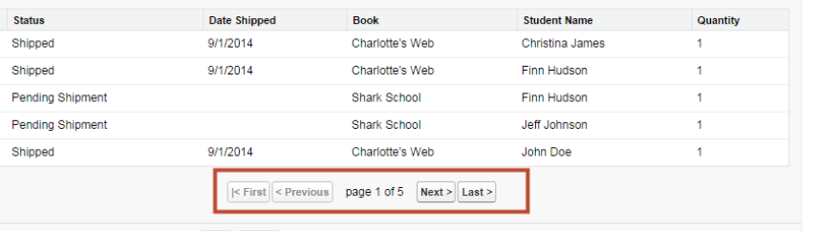

Unit Testing and Code Quality

Create test classes for created Controller/Apex class with minimum of 85% code coverage